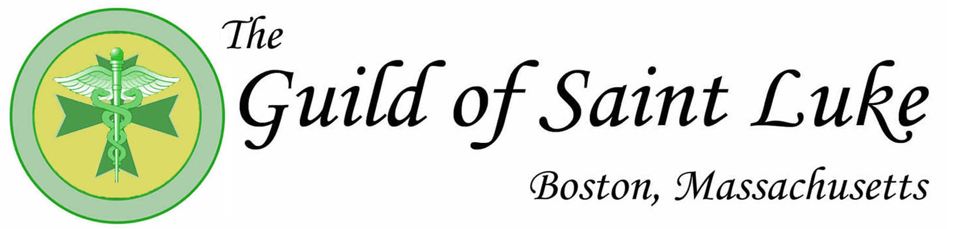
ANNUAL WHITE MASS AND DINNER
Saturday, October 28, 2017, St. John’s Seminary
127 Lake St., Brighton, MA 02135
Mass 5:30 PM, Sean Cardinal O’Malley, Celebrant

Speaker: Rev. Bryan Hehir
Archdiocese Secretary for Health and Social Services
Harvard Kennedy School Montgomery Professor of the Practice of Religion and Public Life
Topic: “Health Care and the Church’s Social Ministry”
-------------------------------------------------------------------------------------------------------------------------------
Physicians in practice: Members/spouses $100.
Nonmembers $125.
Physicians in training: $75.
Medical students: $25.
Please consider an additional amount to help support medical student participation.
Name: Spouse/Guest:

Dinner Selection/s: ___Chicken ___Fish ___Vegetarian
(Indicate number if more than one person)
Dietary Restrictions:

Remit to: Guild of St. Luke c/o Helen Jackson, MD
1180 Beacon St. Ste. 5D
Brookline, MA 02446

